Build a MASA benefit guide landing page

Use the following approved collateral
While you may choose not to host all sections, please do not adjust language with the sections to ensure accuracy of approved description. Instructions are in red text. Sections are highlighted.

Logo (click image to retrieve high-res graphic png format):

svg format: https://masaaccess.com/hubfs/Brand/Logos/MASA_Horizon_754x175-1_svg.svg

Introduction
Medical transport protection from MASA (page header)
About MASA (optional subhead or section head)
Medical Access & Service Advantage (MASA®) is the leading provider of emergency transportation protection, built to enhance healthcare plans by shielding you against the out-of-pocket costs associated with emergency medical transport.
MASA protects more than 2 million members against emergency and non-emergency transportation and provides compassionate services for the challenges often faced after an emergency transport.
The average bill for a ground ambulance ride is $2,086, and $72,469 for an air ambulance ride.¹ No one should have to worry about transport bills during or after an emergency. Unfortunately — even for the insured — these costly bills have become a normal, expected part of emergency care and continue to rise every year.
Supporting image options (click images to retrieve high-res graphic):
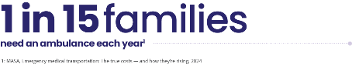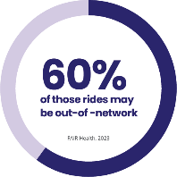

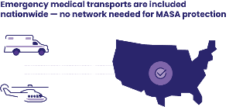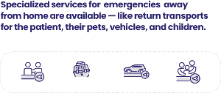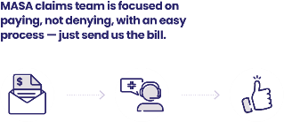

MASA icon library: https://info.masamts.com/hubfs/MASA%20Icons.zip?hsLang=en
--
Informational Video
Learn how MASA fits into your employee benefits
Card image options (click images to retrieve high-res graphic):
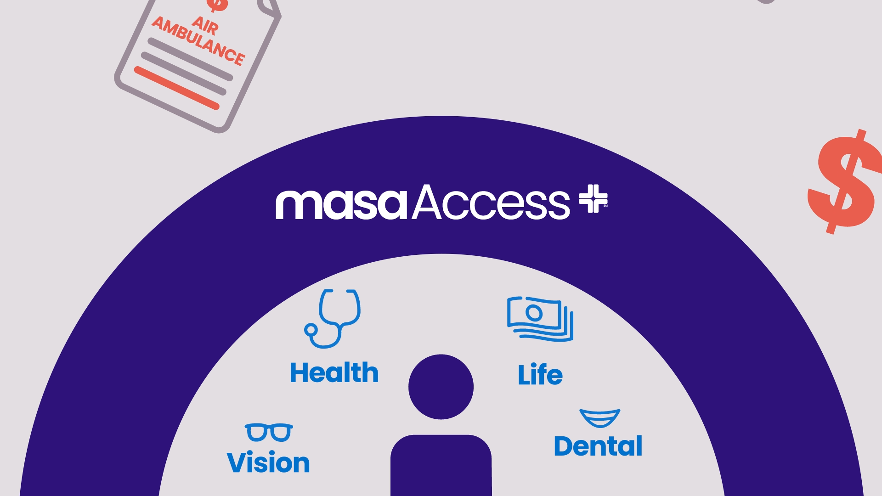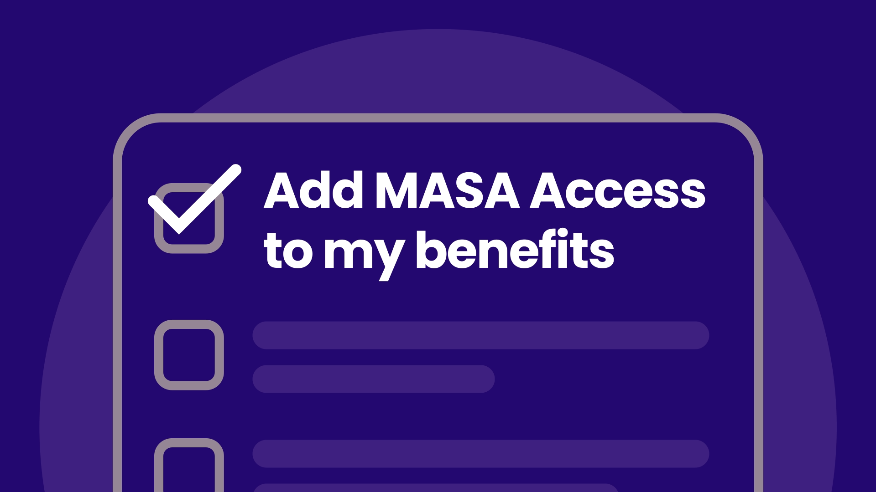
Link of your choice:
Vimeo link: MASA Enrollment Video - Vimeo
Vimeo embed code:
<div style="padding:56.25% 0 0 0;position:relative;"><iframe src="https://player.vimeo.com/video/1049828560?badge=0&amp;autopause=0&amp;player_id=0&amp;a… frameborder="0" allow="autoplay; fullscreen; picture-in-picture; clipboard-write; encrypted-media; web-share" referrerpolicy="strict-origin-when-cross-origin" style="position:absolute;top:0;left:0;width:100%;height:100%;" title="MASA Access Enrollment Video"></iframe></div><script src="https://player.vimeo.com/api/player.js"></script>
MP4 link: https://7942478.fs1.hubspotusercontent-na1.net/hubfs/7942478/GBD/Enrollment%20Materials/MASA%20Access%20Open%20Enrollment%20Video.mp4
--

--
MASA plans for [YEAR]
Explore the following MASA plan(s) to supplement your primary healthcare plan.
[insert plan document links]
Find plan documents under the “coverage” section of this site by state: MASA Partner Success Portal
--
How to access MASA support or request a payment
Getting the most from your membership benefits is simple. Typically, your ambulance bill is what you’ll use to begin your payment request following the emergency. Submit your ambulance bill through the online member portal or by email within 180 days of the emergency.
We understand that some emergencies can lead to added challenges in the immediate days that follow — this is when the MASA Member Services team can provide compassionate, real-time assistance when you need it most.
Member Services: (800) 643-9023
Member portal: masaaccess.com/member
Claims email: ambulanceclaims@masaglobal.com
Smartphone app: MASA Global
--
Stay in touch with the MASA mobile app
Access to emergency transportation solutions is at your fingertips. The MASA mobile app allows you to:
- Access your digital ID card
- View plan documents and benefit
- View your claims history
Links to iOS https://apps.apple.com/us/app/masa-global/id1494256000
Link to Google play store https://play.google.com/store/apps/details?id=com.masa.pts.member.mobile&hl=en_US&gl=US
Supporting image options (click images to retrieve high-res graphic):
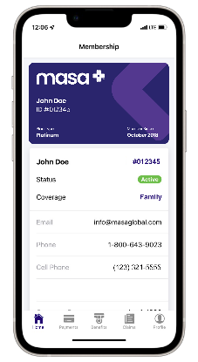
--
Frequently asked questions
Which ambulance company can I use?
Any! In the event of an emergency, simply call 911 and get to the hospital. We have a no-network model where we work directly with the ambulance provider to resolve the bill. Our members and their families are protected from out-of-pocket costs, no matter which provider completes the ambulance transport within the continental United States, Alaska, Hawaii, and Canada.
Will you pay my copay or deductible?
Yes, when it is applicable to your ambulance bill. Our goal is to leave you with complete peace of mind. MASA protection for out-of-pocket costs includes copays, coinsurance, and deductibles associated with your ambulance bill.
When should I call you?
Always call 911 for an emergency. Once you receive a bill from the emergency medical transportation ambulance provider, you can submit it to MASA through the member portal or via email.
Who is protected?
Our family memberships cover you, your partner, and all children under the age of 26 in your household.
How much does an ambulance ride cost?
The average ground ambulance bill is $2,086, and the average air ambulance bill is $72,469.¹ Depending on which provider picks you up, the personnel on board, the care needed, and the number of miles you travel, your bill can get expensive.
Why would an ambulance be out-of-network?
There are over 27,000 ambulance companies operating in the United States.² Some companies are run by cities and states, others are run by local or national private companies. Many insurance plans only cover in-network ground ambulance companies. Even if you’re heading to an in-network hospital, the ground ambulance itself could be out-of-network and leave you with a “balance bill”. We offer protection for ALL ambulance companies operating within the continental United States, Alaska, Hawaii, and while traveling in Canada.
Why might I have to pay out-of-pocket for an ambulance bill?
The ambulance that picks you up may be out-of-network, the reason for your trip may not be deemed a medical necessity, or you might still have to meet your health insurance deductible, copay, or coinsurance. Research shows that there’s nearly a 60% chance you could be responsible for a large portion of your ground emergency transportation bill.³
What is medical necessity?
Medical necessity is established when any other transportation method (besides an ambulance) would endanger the patient’s life. For example, let’s say you’re experiencing symptoms associated with a heart attack and end up taking an ambulance to the hospital. If your health insurance decides that the cause of your symptoms (perhaps indigestion, heartburn, or a panic attack) doesn’t meet their requirements for an ambulance, they could deny your claim and potentially leave you on the hook for thousands of dollars.
--
Sources:
1: MASA group business claims data, 2025. Based upon the enactment of certain legal protections regarding surprise medical billing, actual member liability may be less than the provider's charges.
2: IBISWorld - Industry Market Research - Ambulance Services Industry Report, 2023
3: FAIR Health, 2023
4: National Association of State EMS Officials, 2020
--
Disclaimers and descriptions
This material is for informational purposes only and does not provide any coverage. Not all MASA products and services are available to residents of all states. For a complete list of coverage and exclusions, please refer to the applicable member services agreement or policy for your state. For additional information and disclosures about MASA plans, click or visit: https://info.masaglobal.com/disclaimers
If a member has a high deductible health plan (“HDHP”) that is compatible with a health savings account (“HSA”), benefits may become available under the MASA membership for expenses incurred for medical care (as defined under Internal Revenue Code (IRC) section 213 (d)) once a member satisfies the applicable statutory minimum deductible under IRC section 223(c) for HDHP coverage that is compatible with a HSA.
Out-Of-Pocket Expenses are costs that remain after applying any primary insurance that needs to be paid for by the insured with personal financial resources.

